# ACRM 2018 Longitudinal Data Analysis Workshop

Keith Lohse1, and Al Kozlowski2, 2018-09-07

1 University of Utah; 2 Michigan State University, Mary Free Bed Rehabilitation Hospital

## Practical Session 2: Curvilinear and Higher Order Mixed-Effects Models

This handout is designed to accompany the script you will be working with in the practical session. A copy of the script file, the data, set, and this handout can be found at: <https://github.com/keithlohse/LMER_Clinical_Science>.

The R code is interspersed with explanations below. All R code is highlighted in grey and color coded to show different functions, arguments, and comments in the code.

First, you will need to open the five packages we will be using for this session using the library function:

# Loading the essential libraries.

library**(**"ggplot2"**)**; library**(**"lme4"**)**; library**(**"car"**)**; library**(**"dplyr"**)**; library**(**"lmerTest"**)**;

If you haven’t already installed these packages, you will need to use the install.packages() function first. This can take some time and will require an internet connect.

# If these packages are not installed already, run the following code:

install.packages**(**"ggplot2"**)**; install.packages**(**"lme4"**)**; install.packages**(**"car"**)**; install.packages**(**"dplyr"**)**; install.packages**(**"lmerTest"**)**;

## 2.1 Data Cleaning and Quality Assurance

One of the first steps is to set the working directory. This is a file-pathway that directs R to the folder in which the various data and script files are stored. Make sure the “data_session2.csv” file is saved in that folder and then use the read.csv() function to read the data into R.

##----------------------- Data Cleaning and QA ------------------------------

## Setting the Directory ----------------------------------------------------

getwd**()**

setwd**(**"C:/Users/u6015231/Box Sync/Collaboration/Al Kozlowski/"**)**

list.files**()**

# Make sure that the file data_session2.csv is saved in your working directory.

# Import the .csv file into R.

# We will save this file in the R environment as an object called "DATA".

DATA**<-**read.csv**(**"./data_session2.csv", header **=** **TRUE**, sep**=**",",

na.strings**=**c**(**"NA","NaN"," ",""**))**

# Use the head() function to check the structure of the data file.

head**(**DATA**)**

# Alternately you can also download the data file from the web here:

# DATA <- read.csv("https://raw.githubusercontent.com/keithlohse/LMER_Clinical_Science/master/data/data_session2.csv")

# head(DATA)

At the end of the first module, you might have noticed that although the linear fit was statistically significant, there was a lot of room for improvement. Especially at the early time points (refer to the figures from Session 1) the linear fit was not very accurate, often over-estimating performance for the different participants. As a first step in fitting curvilinear models we want to plot the data for each participant or (at least) a subset of participants.

It is also important to separate curvilinear from truly nonlinear models. Different people might define these terms slight differently, however we will define curvilinear models as curved, but linear in their parameters. Nonlinear models, conversely, are not necessarily curved, nor are they linear in their parameters. For instance, a cubic model is curvilinear, taking the form:

$$y_{ij}=β_{0}+β_{1}\left({Time}_{ij}\right)+β_{2}\left({Time}_{ij}^{2}\right)+β_{3}\left({Time}_{ij}^{3}\right)+ϵ_{ij}$$

Conversely, the negative exponential model has a similar curve, but does not emerge from a linear combination of the its parameters:

$$y_{ij}= α_{i }-(α_{i }- π_{0i})e^{{-π}_{1i}\left({Time}_{ij}\right)}+ε_{ij}$$

We will reserve truly nonlinear models for a later date as fitting these models is often much more complex. However, curvilinear models are very power and, when combined with curvilinear random-effects, can fit unique trajectories for very different individuals. Below, we will walk through visualizing the group-level data and individual linear, quadratic, and cubic models.

## ------------------- Visualizing the Effects of Time ----------------------

# One of the major questions we address in this module is how to best model the effects of time. That is, what is the most appropriate "shape" of the time curve? Is it perfectly straight? Is curved? In this module we will build from our linear model (that we used in Module 1) to a curvilinear model in which we add quadratic and cubic components.

## FIM scores by group and time ---------------------------------------------

g1**<-**ggplot**(**DATA, aes**(**x **=** month, y **=** rasch_FIM**))** **+**

geom_point**(**aes**(**fill**=**as.factor**(**subID**))**, pch**=**21, size**=**2, stroke**=**1.25**)** **+**

geom_line**(**aes**(**group**=**subID**))** **+**

facet_wrap**(~**AIS_grade**)**

g2**<-**g1**+**scale_x_continuous**(**name **=** "Time from Admission (Months)", breaks**=**c**(**0**:**18**))** **+**

scale_y_continuous**(**name **=** "Rasch-Scaled FIM Score (0-100)",limits**=**c**(**0,100**))**

g3 **<-** g2 **+** theme_bw**()** **+**

theme**(**axis.text**=**element_text**(**size**=**14, colour**=**"black"**)**,

axis.title**=**element_text**(**size**=**14,face**=**"bold"**))** **+**

theme**(**strip.text.x **=** element_text**(**size **=** 14**))+**

theme**(**legend.position**=**"none"**)**

plot**(**g3**)**

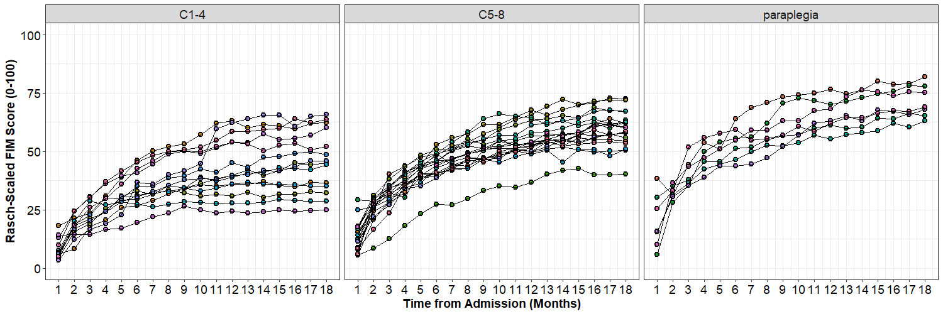

# We can see that these patterns are almost certainly not linear:

first6**<-**DATA**[**c**(**1**:**108**)**,**]**

g1**<-**ggplot**(**first6, aes**(**x **=** month, y **=** rasch_FIM**))** **+**

geom_point**(**aes**(**fill**=**as.factor**(**subID**))**, pch**=**21, size**=**2, stroke**=**1.25**)** **+**

geom_line**()** **+**

stat_smooth**(**method**=**lm, se**=FALSE)+**

facet_wrap**(~**subID**)**

g2**<-**g1**+**scale_x_continuous**(**name **=** "Time from Admission (Months)", breaks**=**c**(**0**:**18**))** **+**

scale_y_continuous**(**name **=** "Rasch-Scaled FIM Score (0-100)",limits**=**c**(**0,100**))+**

ggtitle**(**"Linear Effect of Time"**)**

g3 **<-** g2 **+** theme_bw**()** **+**

theme**(**plot.title **=** element_text**(**size**=**16, face**=**"bold", hjust**=**0.5**)**,

axis.text**=**element_text**(**size**=**14, colour**=**"black"**)**,

axis.title**=**element_text**(**size**=**14,face**=**"bold"**)**,

strip.text.x **=** element_text**(**size **=** 14**)**,

legend.position**=**"none"**)**

plot**(**g3**)**

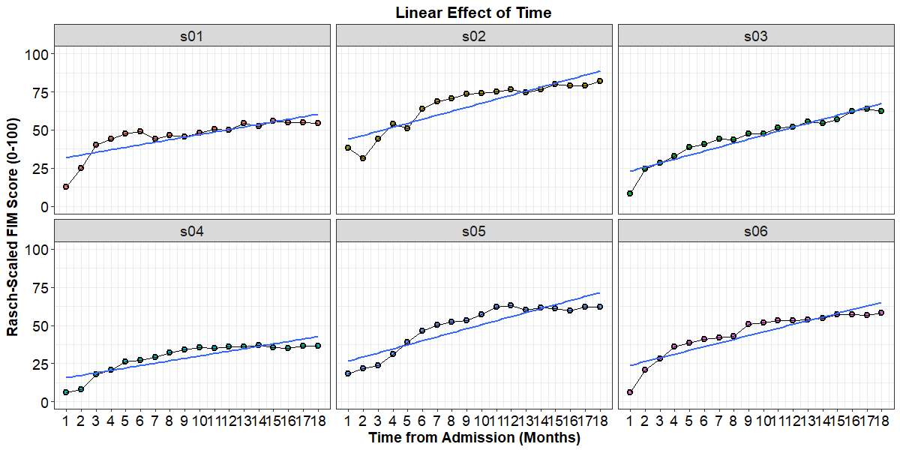

# Visually, we can test the effect of adding a quadratic effect to the model

g1**<-**ggplot**(**first6, aes**(**x **=** month, y **=** rasch_FIM**))** **+**

geom_point**(**aes**(**fill**=**as.factor**(**subID**))**, pch**=**21, size**=**2, stroke**=**1.25**)** **+**

geom_line**()** **+**

stat_smooth**(**method**=**lm, formula **=** y**~**x**+**I**(**x**^**2**)**, se**=FALSE)+**

facet_wrap**(~**subID**)**

g2**<-**g1**+**scale_x_continuous**(**name **=** "Time from Admission (Months)", breaks**=**c**(**0**:**18**))** **+**

scale_y_continuous**(**name **=** "Rasch-Scaled FIM Score (0-100)",limits**=**c**(**0,100**))+**

ggtitle**(**"Quadratic Effect of Time"**)**

g3 **<-** g2 **+** theme_bw**()** **+**

theme**(**plot.title **=** element_text**(**size**=**16, face**=**"bold", hjust**=**0.5**)**,

axis.text**=**element_text**(**size**=**14, colour**=**"black"**)**,

axis.title**=**element_text**(**size**=**14,face**=**"bold"**)**,

strip.text.x **=** element_text**(**size **=** 14**)**,

legend.position**=**"none"**)**

plot**(**g3**)**

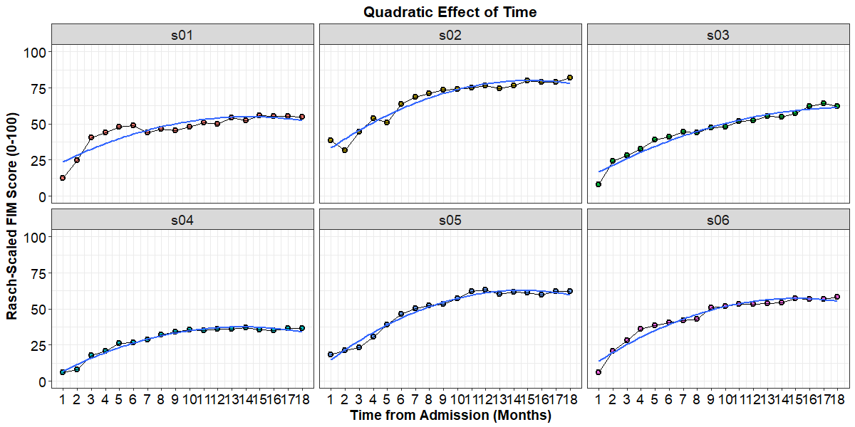

# Further, we can see the effect of adding a cubic effect to the model

g1**<-**ggplot**(**first6, aes**(**x **=** month, y **=** rasch_FIM**))** **+**

geom_point**(**aes**(**fill**=**as.factor**(**subID**))**, pch**=**21, size**=**2, stroke**=**1.25**)** **+**

geom_line**()** **+**

stat_smooth**(**method**=**lm, formula **=** y**~**x**+**I**(**x**^**2**)+**I**(**x**^**3**)**, se**=FALSE)+**

facet_wrap**(~**subID**)**

g2**<-**g1**+**scale_x_continuous**(**name **=** "Time from Admission (Months)", breaks**=**c**(**0**:**18**))** **+**

scale_y_continuous**(**name **=** "Rasch-Scaled FIM Score (0-100)",limits**=**c**(**0,100**))+**

ggtitle**(**"Cubic Effect of Time"**)**

g3 **<-** g2 **+** theme_bw**()** **+**

theme**(**plot.title **=** element_text**(**size**=**16, face**=**"bold", hjust**=**0.5**)**,

axis.text**=**element_text**(**size**=**14, colour**=**"black"**)**,

axis.title**=**element_text**(**size**=**14,face**=**"bold"**)**,

strip.text.x **=** element_text**(**size **=** 14**)**,

legend.position**=**"none"**)**

plot**(**g3**)**

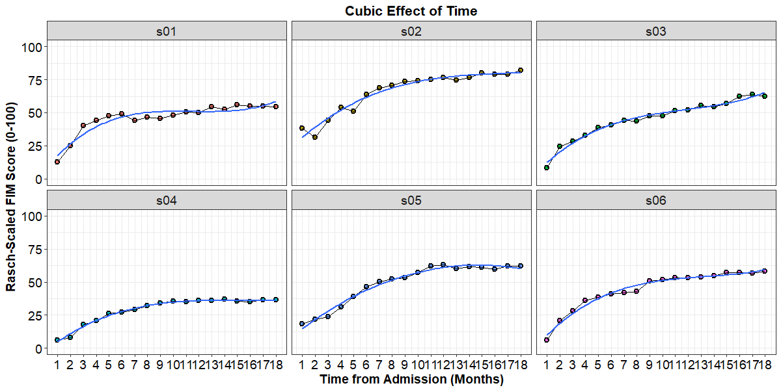

## 2.2 Comparing Different Effects of Time

In order to quantify what our visualizations show us qualitatively, we need to statistically compare models with linear, quadratic, and cubic effects of time.

DATA**$**year.0_sq**<-**DATA**$**year.0**^**2

DATA**$**year.0_cu**<-**DATA**$**year.0**^**3

# Linear Effect of Time

time_linear**<-**lmer**(**rasch_FIM**~**

# Fixed-effects

1**+**year.0**+**

# Random-effects

**(**1**+**year.0**|**subID**)**, data**=**DATA, REML**=FALSE)**

summary**(**time_linear**)**

Linear mixed model fit by maximum likelihood t-tests use Satterthwaite approximations to degrees of

freedom [lmerMod]

Formula: rasch_FIM ~ 1 + year.0 + (1 + year.0 | subID)

Data: DATA

**AIC BIC logLik deviance df.resid**

4794.8 4822.3 -2391.4 4782.8 714

Scaled residuals:

Min 1Q Median 3Q Max

-4.7756 -0.4913 0.1596 0.6602 2.0907

**Random effects:**

Groups Name Variance Std.Dev. Corr

subID (Intercept) 47.83 6.916

year.0 50.82 7.129 0.37

Residual 33.77 5.811

Number of obs: 720, groups: subID, 40

**Fixed effects:**

**Estimate Std. Error df t value Pr(>|t|)**

(Intercept) 26.589 1.170 40.000 22.73 <2e-16 ***

year.0 25.857 1.233 40.000 20.96 <2e-16 ***

---

Signif. codes: 0 ‘***’ 0.001 ‘**’ 0.01 ‘*’ 0.05 ‘.’ 0.1 ‘ ’ 1

Correlation of Fixed Effects:

(Intr)

year.0 0.189

# Quadratic Effect of Time

time_square**<-**lmer**(**rasch_FIM**~**

# Fixed-effects

1**+**year.0**+**year.0_sq**+**

# Random-effects

**(**1**+**year.0**+**year.0_sq**|**subID**)**, data**=**DATA, REML**=FALSE)**

summary**(**time_square**)**

Linear mixed model fit by maximum likelihood t-tests use Satterthwaite approximations to degrees of

freedom [lmerMod]

Formula: rasch_FIM ~ 1 + year.0 + year.0_sq + (1 + year.0 + year.0_sq | subID)

Data: DATA

**AIC BIC logLik deviance df.resid**

4039.3 4085.0 -2009.6 4019.3 710

Scaled residuals:

Min 1Q Median 3Q Max

-4.4894 -0.5194 0.0454 0.5442 3.0358

**Random effects:**

Groups Name Variance Std.Dev. Corr

subID (Intercept) 46.224 6.799

year.0 242.048 15.558 0.07

year.0_sq 44.135 6.643 -0.08 -0.93

Residual 9.754 3.123

Number of obs: 720, groups: subID, 40

**Fixed effects:**

**Estimate Std. Error df t value Pr(>|t|)**

(Intercept) 18.103 1.120 40.000 16.17 <2e-16 ***

year.0 64.044 2.666 40.000 24.03 <2e-16 ***

year.0_sq -26.956 1.262 40.000 -21.36 <2e-16 ***

---

Signif. codes: 0 ‘***’ 0.001 ‘**’ 0.01 ‘*’ 0.05 ‘.’ 0.1 ‘ ’ 1

Correlation of Fixed Effects:

(Intr) year.0

year.0 -0.030

year.0_sq 0.049 -0.921

# Cubic Effect of Time

time_cube**<-**lmer**(**rasch_FIM**~**

# Fixed-effects

1**+**year.0**+**year.0_sq**+**year.0_cu**+**

# Random-effects

**(**1**+**year.0**+**year.0_sq**+**year.0_cu**|**subID**)**, data**=**DATA, REML**=FALSE)**

summary**(**time_cube**)**

Linear mixed model fit by maximum likelihood t-tests use Satterthwaite approximations to degrees of

freedom [lmerMod]

Formula: rasch_FIM ~ 1 + year.0 + year.0_sq + year.0_cu + (1 + year.0 +

year.0_sq + year.0_cu | subID)

Data: DATA

**AIC BIC logLik deviance df.resid**

3741.4 3810.1 -1855.7 3711.4 705

Scaled residuals:

Min 1Q Median 3Q Max

-4.1697 -0.5265 -0.0002 0.5186 3.5018

**Random effects:**

Groups Name Variance Std.Dev. Corr

subID (Intercept) 42.779 6.541

year.0 635.961 25.218 0.06

year.0_sq 1179.872 34.349 -0.07 -0.88

year.0_cu 213.006 14.595 0.10 0.77 -0.98

Residual 5.481 2.341

Number of obs: 720, groups: subID, 40

**Fixed effects:**

**Estimate Std. Error df t value Pr(>|t|)**

(Intercept) 14.977 1.073 40.000 13.954 < 2e-16 ***

year.0 95.033 4.378 39.990 21.706 < 2e-16 ***

year.0_sq -83.232 6.213 39.990 -13.397 2.22e-16 ***

year.0_cu 26.483 2.698 39.990 9.815 3.30e-12 ***

---

Signif. codes: 0 ‘***’ 0.001 ‘**’ 0.01 ‘*’ 0.05 ‘.’ 0.1 ‘ ’ 1

Correlation of Fixed Effects:

(Intr) year.0 yr.0_s

year.0 -0.041

year.0_sq 0.027 -0.891

year.0_cu 0.001 0.797 -0.981

Now that we have all of these models constructed, we can make a statistical comparison between models using the anova() and the AIC as our index of model fit.

anova**(**time_linear, time_square, time_cube**)**

Data: DATA

Models:

object: rasch_FIM ~ 1 + year.0 + (1 + year.0 | subID)

..1: rasch_FIM ~ 1 + year.0 + year.0_sq + (1 + year.0 + year.0_sq |

..1: subID)

..2: rasch_FIM ~ 1 + year.0 + year.0_sq + year.0_cu + (1 + year.0 +

..2: year.0_sq + year.0_cu | subID)

Df AIC BIC logLik deviance Chisq Chi Df Pr(>Chisq)

object 6 4794.8 4822.3 -2391.4 4782.8

..1 10 4039.3 4085.0 -2009.6 4019.3 763.58 4 < 2.2e-16 ***

..2 15 3741.4 3810.1 -1855.7 3711.4 307.87 5 < 2.2e-16 ***

---

Signif. codes: 0 ‘***’ 0.001 ‘**’ 0.01 ‘*’ 0.05 ‘.’ 0.1 ‘ ’ 1

The cubic model provides far and away the best fit, however, not the large degrees of freedom in this model (5 more than the quadratic and 9 more than the linear model!). Having 15 degrees of freedom may not seem like a problem right now, but as we add fixed-effect to our model, we might want to have more “room” in the model to add interactions between fixed effects. As such, it might be interesting to compare our model that has cubic fixed- and random-effects to a model that has only a fixed-effect.

# Cubic Fixed-Effect Only

time_cube_fixed**<-**lmer**(**rasch_FIM**~**

# Fixed-effects

1**+**year.0**+**year.0_sq**+**year.0_cu**+**

# Random-effects

**(**1**+**year.0**+**year.0_sq**|**subID**)**, data**=**DATA, REML**=FALSE)**

anova**(**time_cube_fixed, time_cube**)**

# Note that we list time_cube_fixed first as it is the smaller model with fewer degrees of freedom.

Data: DATA

Models:

object: rasch_FIM ~ 1 + year.0 + year.0_sq + year.0_cu + (1 + year.0 +

object: year.0_sq | subID)

..1: rasch_FIM ~ 1 + year.0 + year.0_sq + year.0_cu + (1 + year.0 +

..1: year.0_sq + year.0_cu | subID)

Df AIC BIC logLik deviance Chisq Chi Df Pr(>Chisq)

object 11 3795.6 3845.9 -1886.8 3773.6

..1 15 3741.4 3810.1 -1855.7 3711.4 62.181 4 1.009e-12 ***

---

Signif. codes: 0 ‘***’ 0.001 ‘**’ 0.01 ‘*’ 0.05 ‘.’ 0.1 ‘ ’ 1

Based on the AIC, it looks like those 4-extra degrees of freedom are worth it and statistically improve our model fit. However, it is worth remembering that you can add fixed- and random-effects for your time variable separately. Occasionally, you might find that a linear random-effect is necessary, but quadratic and cubic random-effects are not, which would imply little variation between individuals in these components. As you build these models, remember that they do not need to be any more complex then necessary and exploring these random-effects of time is an essential first step before moving on to more complicated fixed-effect models.

## 2.3 Conditional Curvilinear Models

As with our linear models, we are interested in how a person’s AIS grade affects not only where they begin, but how they progress through therapy. We will start with our best fitting random-effects model: the cubic model of time:

$$y_{ij}=B_{0}+β_{1}\left({Time}_{ij}\right)+β_{2}\left({Time}_{ij}^{2}\right)+β_{3}\left({Time}_{ij}^{3}\right)+$$

$$U_{0}+U_{1j}\left({Time}_{ij}\right)+U_{2j}\left({Time}_{ij}^{2}\right)+U_{3j}\left({Time}_{ij}^{3}\right)+ϵ_{ij}$$

In the equation, we have highlighted the fixed-effects in blue, the random-effects in red, and random-errors in green. It is important to remember that our AIS grade variable has three levels (“C1-4”, “C5-8”, and “paraplegia”). To test the effects of this variable, therefore, we need two separate contrasts. By default, R will create these contrasts using “treatment coding” (also referred to as “dummy coding”) in which one group serves as a reference against which the other groups are compared. R assigns these levels alphanumerically, so “C1-4” will serve as the reference group. To begin, we will add a main-effect of AIS grade, and the linear interaction of AIS and Time:

$$y_{ij}=B_{0}+β_{1}\left({Time}_{ij}\right)+β_{2}\left({Time}_{ij}^{2}\right)+β_{3}\left({Time}_{ij}^{3}\right)+$$

$$β_{4}\left({C5to8}_{j}\right)+β_{5}\left({Paraplegia}_{j}\right)+β_{6}\left({Time}_{ij}×{C5to8}_{j}\right)+β_{7}\left({Time}_{ij}×{Paraplegia}_{j}\right)+$$

$$U_{0}+U_{1j}\left({Time}_{ij}\right)+U_{2j}\left({Time}_{ij}^{2}\right)+U_{3j}\left({Time}_{ij}^{3}\right)+ϵ_{ij}$$

We have color-coded the main-effect of AIS grade in orange and the linear interactions of AIS and Time in black. Note that AIS grade is only coded by the sub-script “j”, because this variable only changes between participants, it does not vary over time.

From this initial model, we will add quadratic and cubic interactions to see which model provides the best explanation of the data.

# Effect of AIS Grade on Time

cond_01**<-**lmer**(**rasch_FIM**~**

# Fixed-effects

1**+**year.0**\***AIS_grade**+**year.0_sq**+**year.0_cu**+**

# Random-effects

**(**1**+**year.0**+**year.0_sq**+**year.0_cu**|**subID**)**, data**=**DATA, REML**=FALSE)**

summary**(**cond_01**)**

# Effect of AIS Grade on Quadratic Time

cond_02**<-**lmer**(**rasch_FIM**~**

# Fixed-effects

1**+**year.0**\***AIS_grade**+**year.0_sq**\***AIS_grade**+**year.0_cu**+**

# Random-effects

**(**1**+**year.0**+**year.0_sq**+**year.0_cu**|**subID**)**, data**=**DATA, REML**=FALSE)**

summary**(**cond_02**)**

# Effect of AIS Grade on Cubic Time

cond_03**<-**lmer**(**rasch_FIM**~**

# Fixed-effects

1**+**year.0**\***AIS_grade**+**year.0_sq**\***AIS_grade**+**year.0_cu**\***AIS_grade**+**

# Random-effects

**(**1**+**year.0**+**year.0_sq**+**year.0_cu**|**subID**)**, data**=**DATA, REML**=FALSE)**

summary**(**cond_03**)**

# Comparing between Models

anova**(**cond_01, cond_02, cond_03**)**

Data: DATA

Models:

object: rasch_FIM ~ 1 + year.0 * AIS_grade + year.0_sq + year.0_cu +

object: (1 + year.0 + year.0_sq + year.0_cu | subID)

..1: rasch_FIM ~ 1 + year.0 * AIS_grade + year.0_sq * AIS_grade +

..1: year.0_cu + (1 + year.0 + year.0_sq + year.0_cu | subID)

..2: rasch_FIM ~ 1 + year.0 * AIS_grade + year.0_sq * AIS_grade +

..2: year.0_cu * AIS_grade + (1 + year.0 + year.0_sq + year.0_cu |

..2: subID)

Df AIC BIC logLik deviance Chisq Chi Df Pr(>Chisq)

object 19 3711.5 3798.5 -1836.7 3673.5

..1 21 3714.6 3810.8 -1836.3 3672.6 0.8533 2 0.6527

..2 23 3716.5 3821.8 -1835.3 3670.5 2.1146 2 0.3474

Note the large degrees of freedom in these models. Including cubic random-effects and several interactions in the fixed-effects add up quickly! Ultimately, it looks like our first model provides the best explanation of the data based on the AIC:

summary**(**cond_01**)**

Linear mixed model fit by maximum likelihood t-tests use Satterthwaite approximations to degrees of

freedom [lmerMod]

Formula: rasch_FIM ~ 1 + year.0 * AIS_grade + year.0_sq + year.0_cu +

(1 + year.0 + year.0_sq + year.0_cu | subID)

Data: DATA

**AIC BIC logLik deviance df.resid**

3711.5 3798.5 -1836.7 3673.5 701

Scaled residuals:

Min 1Q Median 3Q Max

-4.3757 -0.5280 0.0089 0.5130 3.3788

**Random effects:**

Groups Name Variance Std.Dev. Corr

subID (Intercept) 21.488 4.636

year.0 594.874 24.390 -0.33

year.0_sq 1179.874 34.349 0.21 -0.88

year.0_cu 213.006 14.595 -0.15 0.77 -0.98

Residual 5.481 2.341

Number of obs: 720, groups: subID, 40

**Fixed effects:**

**Estimate Std. Error df t value Pr(>|t|)**

(Intercept) 9.083 1.260 43.160 7.209 6.28e-09 ***

year.0 91.906 4.426 45.790 20.765 < 2e-16 ***

AIS_gradeC5-8 7.022 1.608 40.000 4.367 8.66e-05 ***

AIS_gradeparaplegia 14.619 2.113 40.000 6.918 2.44e-08 ***

year.0_sq -83.232 6.213 40.030 -13.397 2.22e-16 ***

year.0_cu 26.483 2.698 40.020 9.815 3.28e-12 ***

year.0:AIS_gradeC5-8 4.048 1.968 40.000 2.057 0.0462 *

year.0:AIS_gradeparaplegia 6.879 2.586 40.000 2.660 0.0112 *

---

Signif. codes: 0 ‘***’ 0.001 ‘**’ 0.01 ‘*’ 0.05 ‘.’ 0.1 ‘ ’ 1

Correlation of Fixed Effects:

(Intr) year.0 AIS_C5 AIS_gr yr.0_s yr.0_c y.0:AIS_C

year.0 -0.281

AIS_grdC5-8 -0.735 0.047

AIS_grdprpl -0.559 0.035 0.438

year.0_sq 0.181 -0.859 0.000 0.000

year.0_cu -0.144 0.768 0.000 0.000 -0.981

y.0:AIS_C5- 0.134 -0.256 -0.182 -0.080 0.000 0.000

yr.0:AIS_gr 0.102 -0.195 -0.080 -0.182 0.000 0.000 0.438

## 2.4 Checking the Assumptions of our Best Fitting Model

## Level 1 Assumptions ----

# Normality

qqnorm**(**resid**(**cond_01**))**

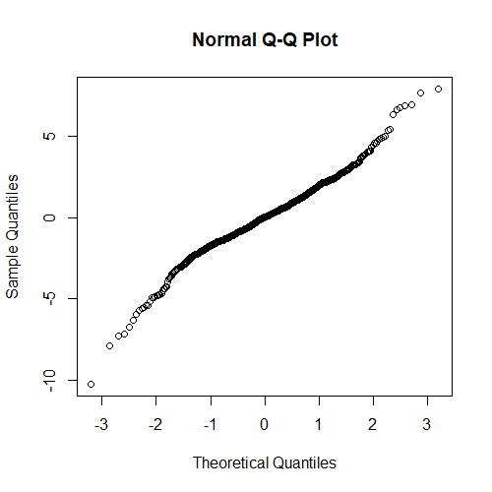

# Homoscedasticity

# Comparable Variances at Level 1

x **<-** fitted**(**cond_01**)**

y **<-** resid**(**cond_01**)/**sd**(**resid**(**cond_01**))**

plot**(**x**=**x, y**=**y, xlab **=** "Fitted Values", ylab**=**"Standardized Residuals",

ylim**=**c**(-**4,4**))**

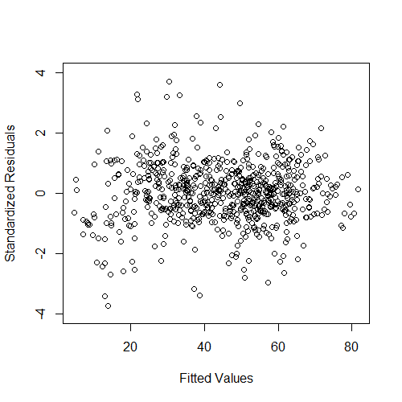

# Influential Participants

plot**(**DATA**$**subID, resid**(**cond_01**)/**sd**(**resid**(**cond_01**))**,

ylab**=**"Standardized Residuals", xlab**=**"Subject ID",

ylim**=**c**(-**4,4**))**

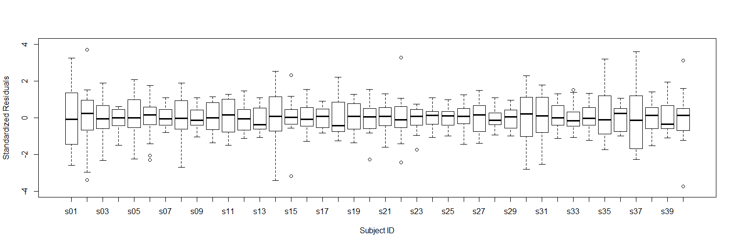

## Level 2 Assumptions ----

LVL2**<-**summarize**(**group_by**(**DATA, subID**)**,

AIS_grade **=** AIS_grade**[**1**])**

head**(**LVL2**)**

ranef**(**cond_01**)**

LVL2**$**RE_int**<-**ranef**(**cond_01**)$**subID**$**`**(**Intercept**)**`

LVL2**$**STD_int**<-**LVL2**$**RE_int**/**sd**(**LVL2**$**RE_int**)**

LVL2**$**RE_year**<-**ranef**(**cond_01**)$**subID**$**year.0

LVL2**$**STD_year**<-**LVL2**$**RE_year**/**sd**(**LVL2**$**RE_year**)**

LVL2**$**RE_year_sq**<-**ranef**(**cond_01**)$**subID**$**year.0_sq

LVL2**$**STD_year_sq**<-**LVL2**$**RE_year_sq**/**sd**(**LVL2**$**RE_year_sq**)**

LVL2**$**RE_year_cu**<-**ranef**(**cond_01**)$**subID**$**year.0_cu

LVL2**$**STD_year_cu**<-**LVL2**$**RE_year_cu**/**sd**(**LVL2**$**RE_year_cu**)**

head**(**LVL2**)**

# Normality of Random-Effects

qqnorm**(**LVL2**$**RE_int**)**

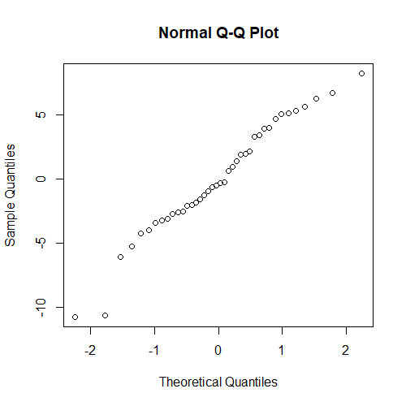

qqnorm**(**LVL2**$**RE_year**)**

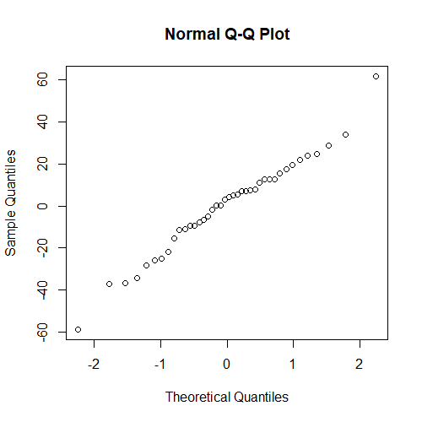

qqnorm**(**LVL2**$**RE_year_sq**)**

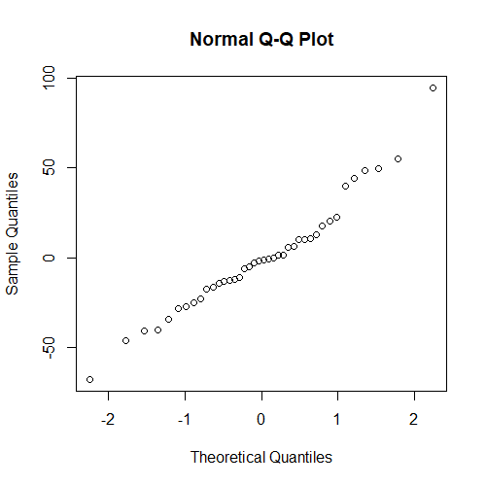

qqnorm**(**LVL2**$**RE_year_cu**)**

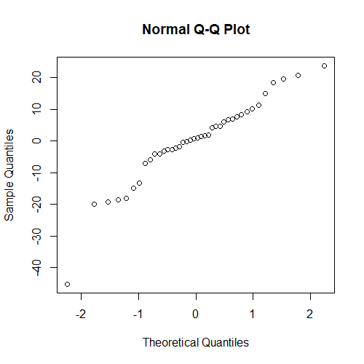

# Homoscedasticity

plot**(**x**=**LVL2**$**AIS_grade, y**=**LVL2**$**STD_int,

xlab **=** "Fitted Values", ylab**=**"Standardized Residuals",

ylim**=**c**(-**4,4**))**

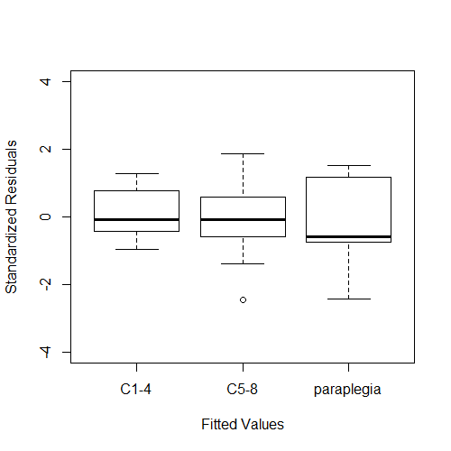

plot**(**x**=**LVL2**$**AIS_grade, y**=**LVL2**$**STD_year,

xlab **=** "Fitted Values", ylab**=**"Standardized Residuals",

ylim**=**c**(-**4,4**))**

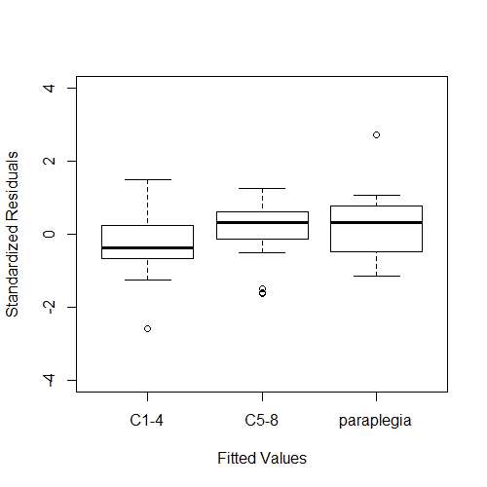

plot**(**x**=**LVL2**$**AIS_grade, y**=**LVL2**$**STD_year_sq,

xlab **=** "Fitted Values", ylab**=**"Standardized Residuals",

ylim**=**c**(-**4,4**))**

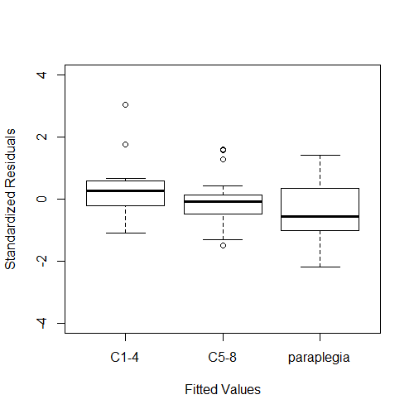

plot**(**x**=**LVL2**$**AIS_grade, y**=**LVL2**$**STD_year_cu,

xlab **=** "Fitted Values", ylab**=**"Standardized Residuals",

ylim**=**c**(-**4,4**))**

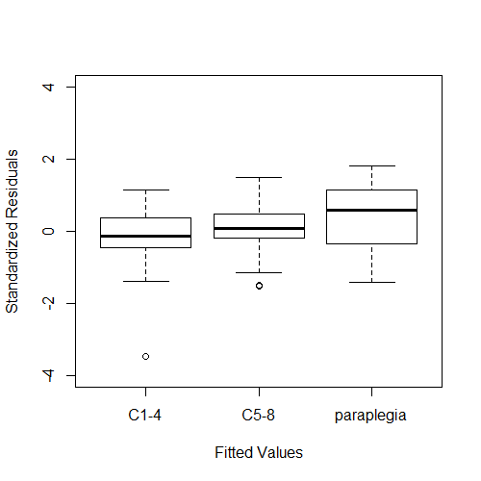

# Influential Participants

plot**(**x**=**LVL2**$**subID, y**=**LVL2**$**STD_int,

xlab**=**"Subject ID", ylab**=**"Standardized Residual",

ylim**=**c**(-**4,4**))**

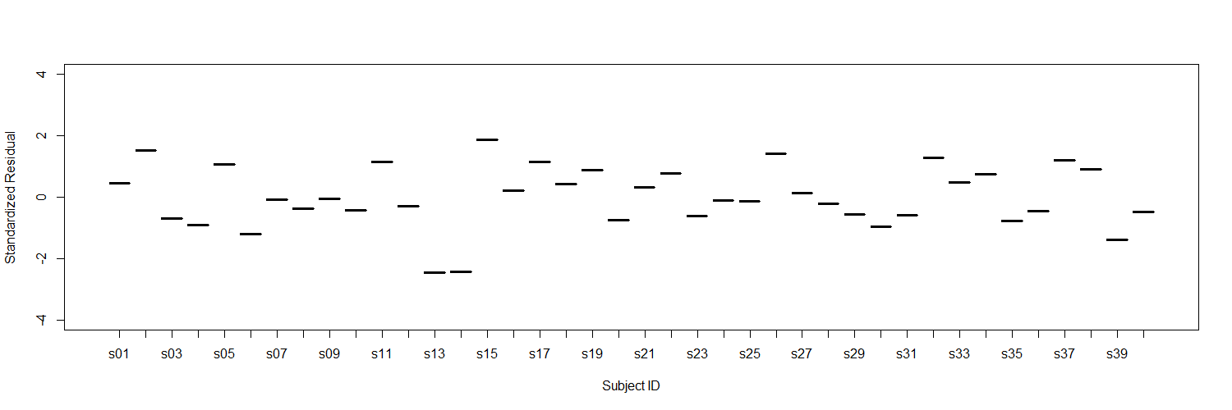

plot**(**x**=**LVL2**$**subID, y**=**LVL2**$**STD_year,

xlab**=**"Subject ID", ylab**=**"Standardized Residual",

ylim**=**c**(-**4,4**))**

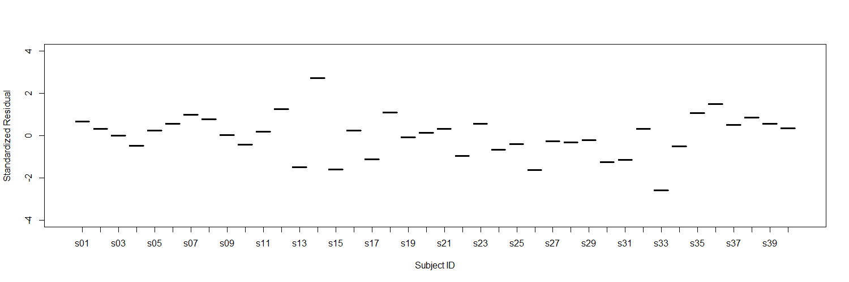

plot**(**x**=**LVL2**$**subID, y**=**LVL2**$**STD_year_sq,

xlab**=**"Subject ID", ylab**=**"Standardized Residual",

ylim**=**c**(-**4,4**))**

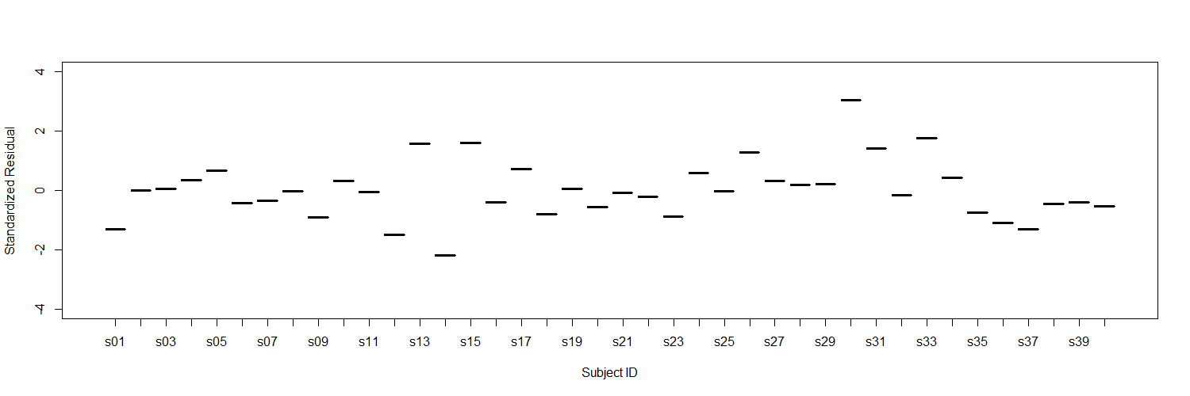

plot**(**x**=**LVL2**$**subID, y**=**LVL2**$**STD_year_cu,

xlab**=**"Subject ID", ylab**=**"Standardized Residual",

ylim**=**c**(-**4,4**))**

